

|  |
| --- |
| **Security Assessment of a Web Application**  **David Cox**  CMP319: Web Application Penetration Testing  **BSc (Hons) Ethical Hacking Year 3**  2023/2024 |

*Note that Information contained in this document is for educational purposes.*

# Abstract

Astley Jewellers are a jewellery company that have recently requested a penetration test of their website, they have approached an independent penetration tester and requested that they provide a report with their findings of the website as well as any mitigations that should be taken to prevent the vulnerabilities from being found on the website, from being exploited.

This report covers a thorough penetration test of the website, utilising the OWASP Web Application Testing methodology. The tester has chosen this methodology due to the wide range of tests that are covered in the methodology, and decided to follow the methodology to ensure that the website is tested logically, thoroughly and to a great detail to ensure that all bases have been covered and any possible issues with the website can identified and mitigated.

Throughout the penetration test, the tester uncovered numerous vulnerabilities including SQL Injection, Directory Traversal and Cross Site Scripting. The vulnerabilities found by the tester allowed them to gain complete control over the website through weak admin credentials and gave them the ability to alter the website in any way that the tested pleased. The following report will cover in-depth the steps taken by the tester to reproduce every vulnerability found whilst also providing adequate steps to mitigate and prevent those vulnerabilities from being exploited and thus preventing malicious actors from gaining privileged access to the website, and potentially the infrastructure hosting the website.

Contents

1 Abstract 1

2 Introduction 1

2.1 Background 1

2.2 Aims 1

3 Procedure and Results 3

3.1 Overview of Procedure 3

3.2 Information Gathering 3

3.2.1 Fingerprint Web Server 3

3.2.2 Review Webserver Metafiles for Information Leakage 4

3.2.3 Enumerate Applications on Webserver 5

3.2.4 Review Webpage Content for Information Leakage 6

3.2.5 Identify Application Entry Points 7

3.2.6 Map Execution Paths Through Application 7

3.2.7 Fingerprint Web Application Framework 8

3.3 Configuration and Deployment Management Testing 9

3.3.1 Test Application Platform Configuration 9

3.3.2 Enumerate Infrastructure and Application Admin Interfaces 10

3.3.3 Test HTTP Strict Transport Security 11

3.4 Identity Management Testing 12

3.4.1 Test Role Definitions 12

3.4.2 Test User Registration Process 13

3.4.3 Test Account Provisioning Process 14

3.4.4 Testing for Account Enumeration and Guessable User Account 15

3.4.5 Testing for Weak or Unenforced Username Policy 16

3.5 Authentication Testing 18

3.5.1 Testing Credentials Transported Over an Encrypted Channel 18

3.5.2 Testing for Default Credentials 19

3.5.3 Testing for Weak Lock Out Mechanism 20

3.5.4 Testing for Weak Password Policy 21

3.6 Authorisation Testing 22

3.6.1 Testing Directory Traversal File Include 22

3.7 Session Management Testing 23

3.7.1 Testing for Session Management Schema 23

3.7.2 Testing for Cookie Attributes 25

3.7.3 Testing for Session Fixation 25

3.7.4 Testing for Logout Functionality 26

3.8 Input Validation Testing 28

3.8.1 Testing for Reflected Cross Site Scripting 28

3.8.2 Testing for Stored Cross Site Scripting 28

3.8.3 Testing for SQL Injection 29

3.8.4 Testing for Incubated Vulnerability 30

3.9 Error Handling 33

3.9.1 Testing for Improper Error Handling 33

3.10 Testing for Weak Cryptography 33

3.10.1 Testing for Weak Transport Layer Security 33

3.11 Business Logic Testing 34

3.11.1 Test Business Logic Data Validation 34

3.11.2 Test Ability to Forge Requests 35

3.11.3 Test Number of Times a Function Can Be Used Limits 35

3.11.4 Test Defences Against Application Misuse 35

3.11.5 Test Upload of Unexpected File Types 35

4 Discussion 36

4.1 Overall Discussion 36

4.2 Mitigations for Vulnerabilities Found 36

4.2.1 Robots.txt information leakage 36

4.2.2 Source code information leakage 37

4.2.3 Installation files information leakage 37

4.2.4 No HTTPS 37

4.2.5 User Enumeration 38

4.2.6 Unlimited login attempts 38

4.2.7 Local File Inclusion (LFI) 39

4.2.8 Insecure cookie encryption 39

4.2.9 Directory Browsing 40

4.2.10 File Filter Bypass 40

4.2.11 SQL Injection 41

4.2.12 Weak Administrator Credentials 41

4.2.13 Cross-Site Scripting 42

4.3 Future Work 42

5 Bibliography 43

Appendices 45

Appendix A1 – Table of Abnormal Response Codes 45

Appendix A2 – Table of Variable Fields 45

Appendix B – OWASP ZAP REPORT 46

Appendix C – Gobuster Output 56

Appendix D – Nikto Output 59

Appendix E-1 – CSS Directory Contents 60

Appendix E-2 – Includes Directory Contents 61

Appendix E-3 – CGI-BIN Contents 62

Appendix E-4 – Icons Directory Content 63

Appendix E-5 Image Directory Content 64

# Introduction

## Background

In modern society, having an online presence is a requirement for businesses to survive. In the month of August 2023, it is estimated that 24.9% of total retail sales, were made online (Lewis, 2023). Although this percentage has slowly been decreasing as the world has been recovering from the COVID-19 pandemic, the need to maintain good security of a business’s infrastructure, particularly their website security has not decreased. A report from 2020 surveyed 2,152 IT security personnel, 60% of these personnel reported that they had been victim to a cybercrime in the past 12 months, and 36% of those attacks were web-based attacks. (Keeper Security Inc, 2020). Web application security testing is becoming more important and vital to protect not only business data and intellectual property, but also consumer data.

Businesses that are not prepared for the growing eventuality that they will be hit by some kind of cyber-attack, will often find themselves being forced to pay hundreds of thousands of pounds, large damage to the company reputation and a drop in share price. Furthermore, depending on the type of attack, an impact on productivity further hindering profits and production. Although the statistics do not lie, and it is becoming more likely that businesses are ever-more likely to be hit by cyber-attacks, preparation is all that can be expected of them.

Rick Astley, owner of Astley Jewellers, has contacted an independent penetration tester and requested that they perform a penetration test on his website and display their findings in a report. The tester had an instance of the website and a set of credentials so that the tester could test every aspect of the website without affecting real-time services.

## Aims

The tester aims to determine any vulnerabilities within the web application and produce them in a report that is to be given to the client. Throughout the test, the tester will aim to put themselves in the position of a malicious actor as to best simulate what would happen in a real attack, meaning that they will attempt to escalate their privileges on the web application and the machine hosting the website, deface the website and steal as much information as possible.

To achieve their aims, as listed above, the tester intended to make use of an industry standard methodology, OWASP Web Application Security Testing and therefore make use of a large variety of tools in an attempt to meet their goals. Further information regarding the methodology selected by the penetration tester can be located in the Procedure sections. The tester decided to use this methodology due to the breadth of vulnerabilities that it covers and therefore allowing for as many opportunities to uncover weaknesses within the web application to be revealed and thus countermeasures that can be implemented to help improve the overall security of the web application.

# Procedure and Results

## Overview of Procedure

As previously mentioned, the tester has decided to make use of the OWASP Web Application Security Testing methodology (OWASP, 2023). The tester chose this methodology as it is maintained by a reliable company and contains a wide variety of tests, therefore allowing for the tester to produce an in-depth report whilst maintaining a logical thought process.

This methodology consists of 12 steps, which are:

1. Information Gathering
2. Configuration and Deployment Management Testing
3. Identity Management Testing
4. Authentication Testing
5. Authorisation Testing
6. Session Management Testing
7. Input Validation Testing
8. Testing for Error Handling
9. Testing for Weak Cryptography
10. Business Logic Testing
11. Client-side Testing
12. API Testing

Throughout this penetration test, the tester made use of tools that are recommended in the methodology they are following, as well as some tools that are not mentioned in the methodology. They used Kali Linux as their Operating System, which was installed on a virtual machine with all of the tools that come installed with a default installation of the operating system, and installed some tools not included in a base install such as OWASP Zap and Mantra.

## Information Gathering

### Fingerprint Web Server

Fingerprinting a web server is the process of identifying the various services and service versions that are running on a server. This can include banner grabbing and other methods which attempt to leak basic service information regarding the web server.

The tester ran the “nmap” command which is a tool commonly used to assist with network mapping and gaining a basic understanding of a server’s configuration (Kali Linux, 2023). The tester ran this command with the flags, “-sCV” which is a combination of the “-sC” and “-sV” flags. “-sV” for version detection and “-sC” for default scripts. The tester also included the “-oN” flag as to save the output of the command to a file for future use.

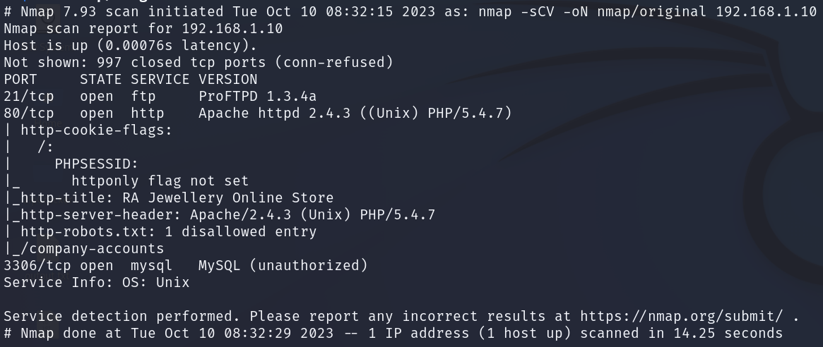

Figure 1 - Nmap Command and Output

From the testers scan, we can see that there are three services running on the server.

* Port 21 - ProFTPD 1.3.4.a
* Port 80 – Apache httpd 2.4.3, running PHP at version 5.4.7
  + We can see there is one entry to a robots.txt file – “/company_accounts”
* Port 3306 – MySQL, unknown version

From this information the tester is able to focus further exploitation on these services in later stages of the methodology. The tester has noticed a possible attack vector could be to trigger SQL Injection through the webserver, to gain access to the MySQL server and potentially uncover account credentials. The version information for the FTP and HTTP services also allows the tester to look for version specific vulnerabilities that may grant them elevated access.

### Review Webserver Metafiles for Information Leakage

Metafiles on a web server can be identified as anything that is hidden or contained in obfuscated paths or files that allow for a tester to map out or and gain a better understanding of the web server (OWASP, 2023) From the testers nmap scan they realised that on port 80 (HTTP) there was a “robots.txt” file. This file on a webserver is responsible for supplying crawlers and spiders with the relevant information including which user-agents are allowed to spider the network, and any files or folders that are to be ignored when spidering the web server.

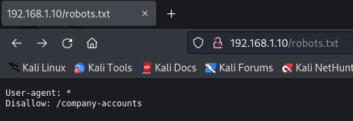

Figure 2 - Robots.txt file

We can see that the contents of the “robots.txt” file does not block any spiders from spidering the webserver, although they are not allowed to spider to “/company-accounts”. The tester then began to explore to this directory and was greeted with a txt file, and a zipped folder. The txt file revealed nothing of importance although after download the zipped folder to the testers machine and unzipping it, the tester uncovered multiple files regarding clients, sales and employees. Something that he would look into later in the test.



Figure 3 - Contents on finances.zip

### Enumerate Applications on Webserver

This stage is similar to section fingerprinting the webserver as the tester is running another command to assess whether there are any services running on abnormal ports that would not have been detected by the original command used in an earlier section. The tester ran the nmap command again, this time with the flags “-Pn” to skip host discovery, “-sT” to specify the scan technique, “-sV” for version detection and “-p0-65535” to specify a port region to search through. The command and its output can be seen in Figure 4 below. 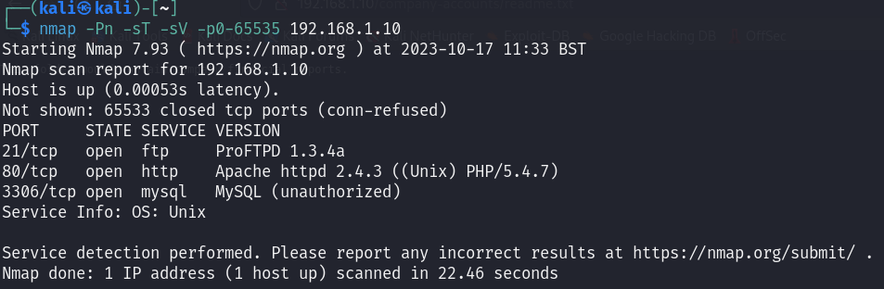

Figure 4 - Further enumeration of the web server

The tester did not notice any important changes between both nmap scans and therefore felt confident focusing all future steps of the methodology on these services as there does not appear to be any other services running that are connected to the host.

### Review Webpage Content for Information Leakage

This part of the methodology requires the tester to look through the code to the webpage to look for comments, metadata and other useful information that may provide further detail and therefore, provide a deeper understanding of the webpage and look for any debug files, that may show issues with the code.

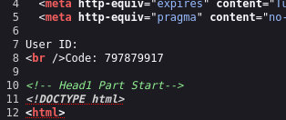

Figure 5 - Code dynamically displayed on the webpage

After looking through the source code of the website, the tester identified that a “user id” and “code” was displayed at the top of any page on the website, every time it was reloaded, although it is out of the HTML flags which implies that it may be dynamically generated, and therefore may be exploitable, although the tester decided to look further into this later in the penetration test.

The tester had also noticed from their Gobuster scans a PHP file called “hidden.php”, it was incredibly small in size and upon visiting it, the tester was greeted with a blank page. Although, after using the developer tools on their browser, they looked at the source code for the page and saw a HTML comment that contained a door entry number. The tester made use of this code as it could come in useful later in the penetration test, or could be useful if the tester were to conduct a physical penetration test against the business at a later date. 

Figure 6 - Comment on hidden.php containing a door code

### Identify Application Entry Points

Through this part of the methodology the tester wanted to identify areas where there were irregular status codes such as 3XX or 403 status codes, as they would imply that there is either some kind of redirect or forbidden access, and therefore something for the tester to investigate further. Identifying entry points can also include login pages, or places that will take data from a user, as there is the possibility for them to be used maliciously. To search for entry points, the tester manually searched through the website and made note of any paths on the web server that returned a status code besides 200 or 404. A table containing the testers results can be found in Appendix A1 and A2.

Looking at Appendix A1, the tester uncovered multiple directories that responded with “301” status codes which indicates that they redirect. When the tester looked for “/cgi-bin/”, it returned a “403” status code which implied that it existed, although they did not have any access to the folder. Finally, the tested uncovered that “/phpMyAdmin” responded with a “401” code, which is a code that indicates the user lacks valid authentication, upon trying to load the page they were asked to input a set of credentials. Furthermore, looking through the data in Appendix A2, the data uncovered multiple entry points that could be vulnerable to SQLI or XSS attacks, and made note of them for further investigation later in the methodology.

### Map Execution Paths Through Application

This part of the tester’s chosen methodology is crucial as it provides a full understanding of the layout of the web server. This was done using a tool recommended by the company whose methodology the tester was using (OWASP ZAP). This tool allowed the user to find a list of every URL associated with the domain in question (192.168.1.10) through the use of the “spider” tool. The spider tool found 473 URLs connected to the domain and generated a full report, including a list of vulnerabilities, which can be found in Appendix B.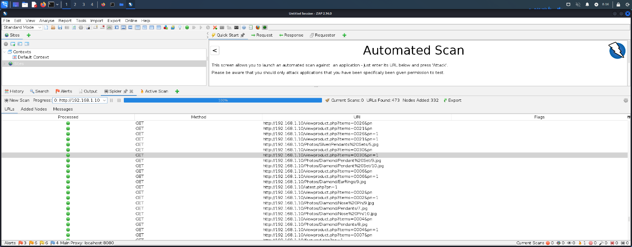

Figure 7 - OWASP ZAP Spider Tool

To support the use of the tool recommended through the OWASP Methodology, the tester also conducted a separate test, searching for directories and specific file types on the web server through the use of a directory bruteforce tool, known as Gobuster. Gobuster is a tool used to brute-force URIs including directories, files and DNS subdomains (Kali Linux, 2023). The command that the tester ran can be seen in Figure 8. The “-u” flag is used to specify the URL, “-w” for the wordlist to be used and “-x” for specific extensions to also search for, as well as directories. The output from this command can be seen in Appendix C.



Figure 8 - Gobuster command

### Fingerprint Web Application Framework

Fingerprinting the target is an imperative part of a penetration test as it is crucial for gaining a basic understanding of the software that is operating on the target, and therefore being able to target future attacks rather than continuing to attack in the dark. Although having previously identified versions of the software running on the server, the tester wanted to confirm this by running additional tests. Through the use of the “curl” command, the tester is able to search for specific HTTP headers that may leak service information. The tester used the “-v” flag, also known as verbose, to display the HTTP headers (Kali Linux, 2023). The tester’s command and output can be seen in Figure 9.

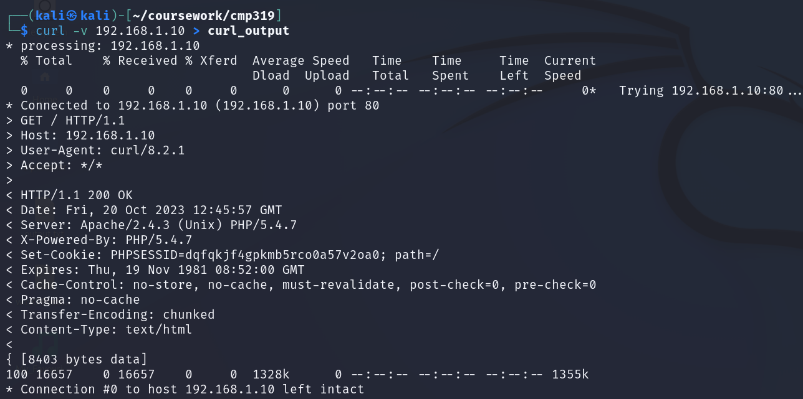

Figure 9 - Curl command & output

The tester noticed the presence of a weird header when analysing the response, in the form of the “X-Powered-By” header, which contained a value which appropriately identified the PHP version being ran on the server. The tester also ran a Nikto which made them aware of multiple HTTP headers that were not included, leaving the website vulnerable to other types of attack. The relevant output from the Nikto scan can be found in Figure 10, whilst the full scan can be found in Appendix D.

Figure 10 - Nikto Header Suggestions

As seen in the Figure above, the Nikto scan also recognised that there was no XSS, or anti-clickjacking headers as well as no “X-Content-Type-Options” header, therefore allowing for the content to be rendered differently to the expected type.

## Configuration and Deployment Management Testing

### Test Application Platform Configuration

Testing an application’s platform configuration primarily consists of three sections; testing for default/known files, debugging files/extensions used in development and any logging systems in the application. The tester made use of “Nikto” which was mentioned in 2.2.7 and the output available in Appendix D and OWASP ZAP which was also mentioned in 2.2.6.

Nikto was used to search the target for vulnerabilities and get the status on whether default/known files were present on the target. 

Figure 11 - Nikto Output #1

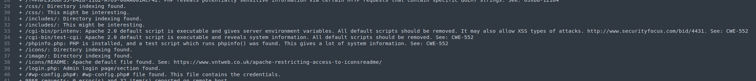

Figure 12 - Nikto Output #2

The tester highlighted two sections of the Nikto scan with the first being that Nikto had identified a vulnerability with the web server that allowed for attackers to bruteforce file names. The second section that the tester highlighted was the default/known files that Nikto identified. Following the output of this command, the tester visited each of the directories identified from the Nikto scan and was able to view the directories and their content. The contents of the directories in Figure 12 can be found in Appendix E1-5.

The tester then moved onto the OWASP ZAP scan, which as previously mentioned generated a report which highlighted multiple vulnerabilities to them. The tester noticed they had received 19 alerts from the ZAP scan and although most of them matched up with the report generated by the tool, made note of the alerts for future testing. 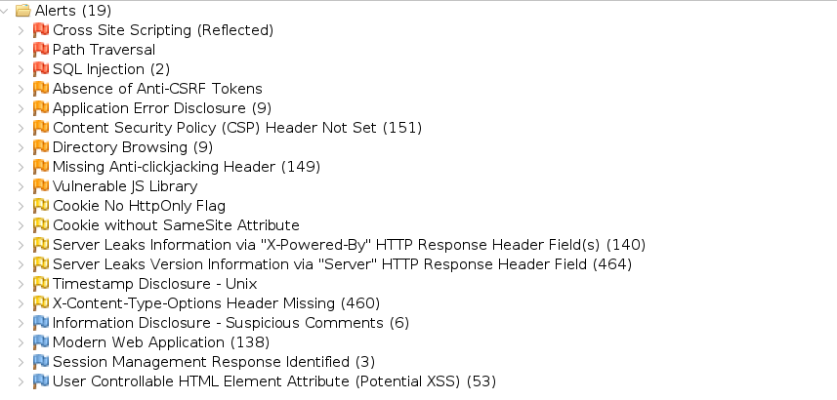

Figure 13 - OWASP ZAP Alerts related to 192.168.1.10

### Enumerate Infrastructure and Application Admin Interfaces

This section of the methodology is focused on uncovering further information regarding any applications that are internet facing and discovering whether there is any unauthorised functionality that can be accessed by the tester. The tester noticed that from their Gobuster scans in Appendix C that there was a directory on the webserver called “/adminarea/” as well as “/phpMyAdmin/”. The tester loaded the website with the /adminarea/ directory and found multiple PHP files that seemed to make up an admin panel, unfortunately when the tester tried to load one of the files, they were greeted with a JavaScript alert that asked them to log in. A screenshot showing the testers findings can be found in Figure 14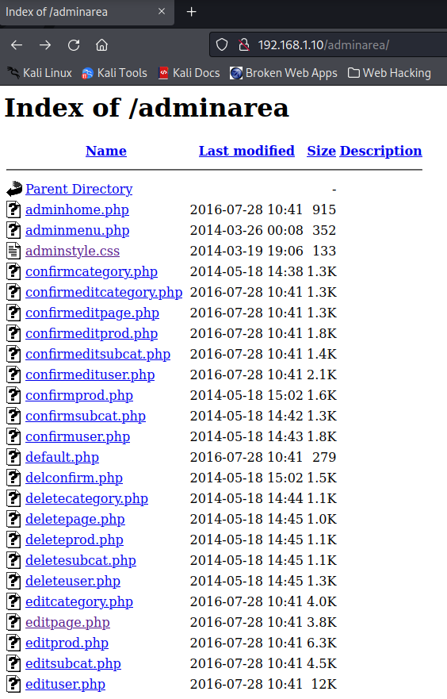

Figure 14 - Contents of /adminarea/

The tester then attempted to explore the /phpMyAdmin/ directory although was unable to access it due to it requiring login credentials that the tester did not have.

### Test HTTP Strict Transport Security

HTTP Strict Transport Security (HSTS) is a feature that enables a web server to inform the clients webserver that it should not establish an unencrypted connection with the domain that it is attempting to, and it should only use HTTPS. Without this header it is possible for someone to conduct a Man in The Middle (MITM) attack and steal user credentials or potentially payment information. This can also be a useful feature for preventing users from overriding certificate errors which could allow them to bypass security features and gain unauthorised access. The tester issued a command that sent a request to the webserver, and would output if the HSTS header was found. As can be seen in Figure 15, the header was not found and therefore showed that the website is insecure.

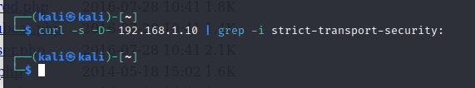

Figure 15 - Testing for HSTS Header

## Identity Management Testing

### Test Role Definitions

This section of the methodology assigns 4 groups that require different levels of permission to a server. These groups are:

* Administrator
  + Responsible for managing the application functionalities.
* Auditor
  + Responsible for reviewing the application transactions and providing a detailed report.
* Support Engineer
  + Responsible for helping the customers debug and fix issues on their accounts.
* Customer
  + Responsible for interacting with the application and benefiting from its services.

Using the tool, sqlmap, the tester attempted to enumerate the database and dump any user credentials although was unsuccessful in uncovering any useful data although the tester was successful with conducting a brute force attack against the login page for the webserver. After conducting the brute force attack and gaining access to the administrative account, the tester identified an “administrator” role and a “user” role. By gaining access to this administrative account, something which would be covered in a later section, the tester had persistence over the web server and noted that the passwords for every account were stored in plaintext and viewable through the admin control panel. This is a security risk as if anyone were to compromise an account with administrative access, then they would have the ability to see any users’ credentials and therefore takeover their account or escalate/remove other accounts permissions, allowing for other users to be given administrative access, or block other administrators from stopping an attacker.

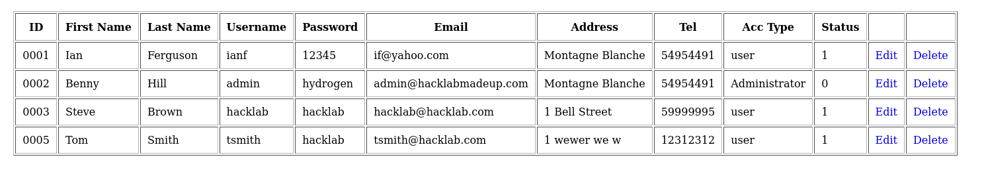

Figure 16 - Database containing all users on the webserver

Furthermore, the tester was also able to alter and delete all content on the web server without any further checks to ensure they were not acting maliciously, such as 2 Factor Authentication. This included the prices and views for certain products, which could allow for an attacker to sell expensive products significantly under the amount that they should be priced.

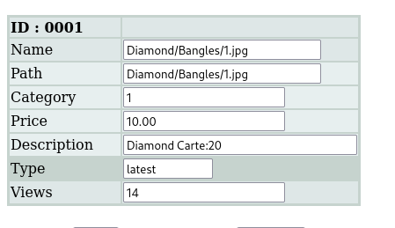

Figure 17 - Editing the price of the product

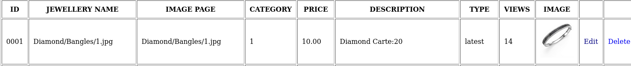

Figure 18 - Confirmation that the price of the product had changed

### Test User Registration Process

This section of the methodology is crucial for user safety, due to the fact that if there is issues with the process of registering new users, then existing customers may be at risk of losing their accounts. After reviewing the source code for the target, the tester was able to deduct that the process of user registration is completely automated, and therefore may have possible misconfigurations such as poor blacklists or lack of string sanitisation. The tester decided to check for XSS and SQLi in this section, as they believed they were attack vectors that would have the highest likelihood of being present.

Before conducting their tests for SQLi and XSS, the tester wanted to check the automation process for a lack of string sanitisation and the ability to perform an account takeover. The account created by the tester can be found in Figure 19A & 19B.

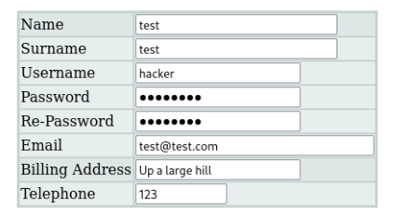

Figure 19A - Credentials on the registration portal



Figure 18B - Confirmation that the account was created

The tester was able to register their account, although noticed that the website does not check the validity of the email address submitted, and therefore there is no need for users to use real email addresses and the lack of password policy. The password policy for the website lackluster and simply required the user to input a string with more than 5 characters, no requirements for uppercase, special or numerical characters. The tester noted these things down as they were areas to be mentioned later in the report when suggesting ways of mitigating against further attacks. The tester then attempted to register using the same email but was unable to, due to adequate checks that would prevent the tester from performing an account takeover through this method although when provided with a different email address but the same username, the tester was able to successfully take over the account they had previously created, showing that although there is some countermeasures in place, that they are neither enough nor coded to an adequate standard. This can be shown in Figure 20.



Figure 20 - Two accounts with the same username but different passwords

### Test Account Provisioning Process

This section of the methodology covers whether an attacker has the capabilities to create and modify the account permissions for other user and administrator accounts. Since the tester had access to the administrative panel, they decided to test whether they could set other users to administrator and then, log into that other account and remove the administrator permissions from the original admin account.

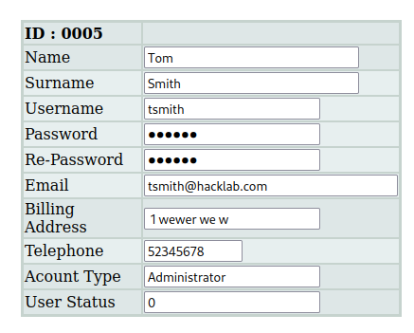

Figure 21 - Changing the user status & account type

The tester found that they were able to change another account with the “user” status to “Administrator”, change the account password and user status without any kind of authentication or issues.

The tester then logged into the “tsmith” account and was greeted with the admin panel. The tester then changed the account status of the “admin” account that they had compromised and was able to do so without any errors. 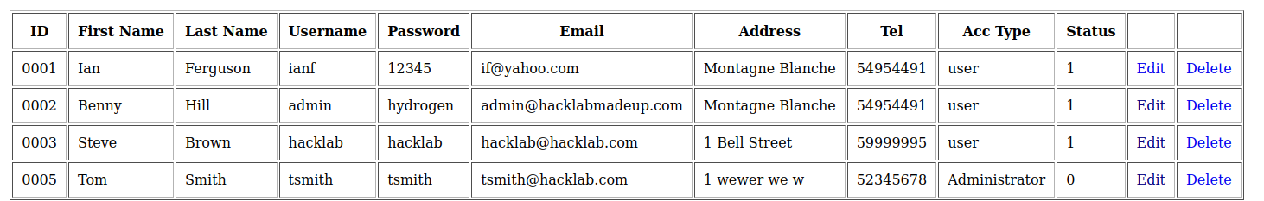

Figure 22 - Showing that the tester had successfully removed the admin accounts privileges.

The tester made the note of these capabilities as something to expand on when suggesting ways that the site owner could improve their security.

### Testing for Account Enumeration and Guessable User Account

The tester had noticed that whilst checking for account credentials that they were able to identify valid usernames as, if they had input a valid username but the wrong password they would be told that the password was invalid, although an incorrect username would show “username was invalid”. 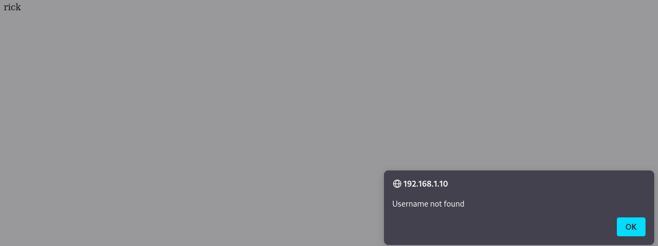

Figure 23 - Showing the response for an invalid username

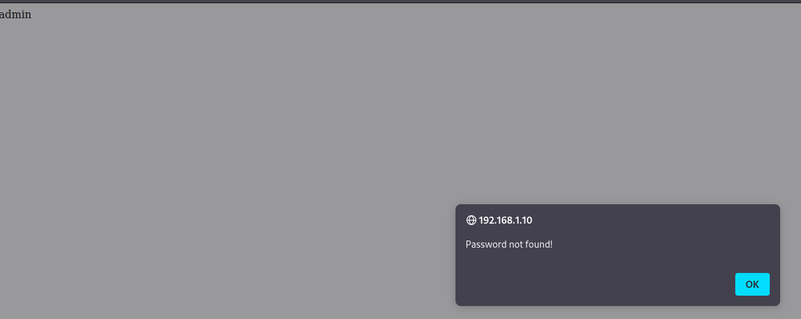

Figure 24 - Showing the response for a valid username

Using this technique, the tester was able to enumerate the presence of multiple accounts which allowed them to target specific accounts for further attacks including bruteforce password-cracking and account takeover attacks.

### Testing for Weak or Unenforced Username Policy

To test for weak username policies the tester attempted to create account names with exceptionally long and short lengths, with one character and 32 characters to see whether there were any limits as to what the username policy for this website was.

Through the screenshots in Figure 25 & 26 the tester proved that they were able to create and log into accounts with account names ranging from one character to 32, proving that there did not appear to be any kind of username policy.

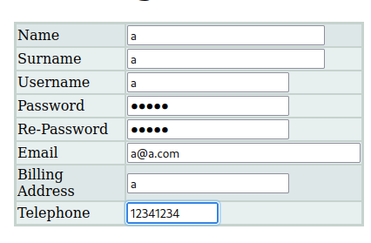

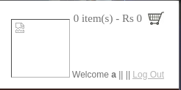

Figure 25 - Proof of creation and login for an account with a 1 character username

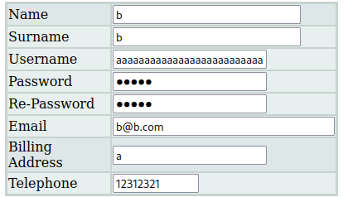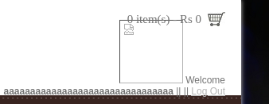

Figure 26 - Proof of creation and login for an account with a 32 character username

## Authentication Testing

### Testing Credentials Transported Over an Encrypted Channel

For sensitive information such as credentials or banking information it is essential that this information is encrypted as to protect the customer from the possibility of individuals sniffing packets and getting access to this sensitive information. The common method for implementing this is through the “HTTPS” protocol, which ensures that all data transferred is encrypted as opposed to the predecessor “HTTP”.

The tester decided at this point to test what headers were transported between the client and server when a user would request a sensitive part of the website, such as the login page. The tester utilised the Curl library on their Kali Linux virtual machine to see what information was leaked when trying to load the login page for Astley Jewellers. The tester used the flag “-kis” which specifies an insecure connection which means that it would use the HTTP protocol instead of attempting to use the HTTPS protocol and ensures that the output will include the headers.

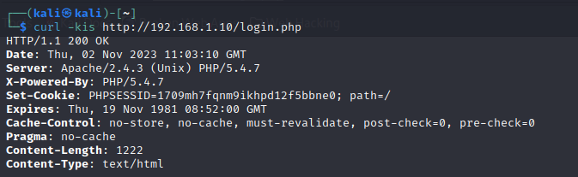

Figure 27 - Curl command output

The tester noticed from the output found in Figure 27 that a “PHPSESSID” cookie is set and there was no sign of a cookie that prevented the request from being sent over HTTP, both of these things pointed towards an attacker from having the capabilities to hijack other user’s cookies. The tester then used the developer tools on the Firefox browser and noticed an additional “SecretCookie” which is something the tester would investigate further in a later section.



Figure 28 - Developer Tools showing the presence of a SecretCookie

### Testing for Default Credentials

The tester decided that it was worth testing the application to see whether there were default credentials present, either through third party services that were running on the website or if the website owner had left developer or administrator credentials using common combinations. The tester tried multiple combinations including:

* Rick/admin
* Admin/admin
* Admin/rick
* Rick/password
* Admin/password

The tester did not gain access to any account with any of the combinations listed above although as mentioned in Section 2.4.4 the tester was able to identify the existence of an account with the username “admin” although no indication of an account called “rick”.

### Testing for Weak Lock Out Mechanism

Lock out mechanisms are often used by developers to prevent attackers from being able to use bruteforce attacks against their services. These mechanisms often monitor a users attempts at logging into their account to see how many times they have tried to do so over a short span of time, and if they have tried it too many times and failed over a short period of time then they may be locked out from trying again for a certain period of time, as to significantly slow down and eliminate brute force attacks.

The tester showed this through their method of gaining the password for the “admin” account. They started by capturing a request of them attempting to log into the admin account and loading it up in OWASP ZAP and then passing it to the “Fuzz” tool which would allow them to bruteforce the password. The tester then edited the request and set up the request to use the “RockYou” wordlist in the correct place.

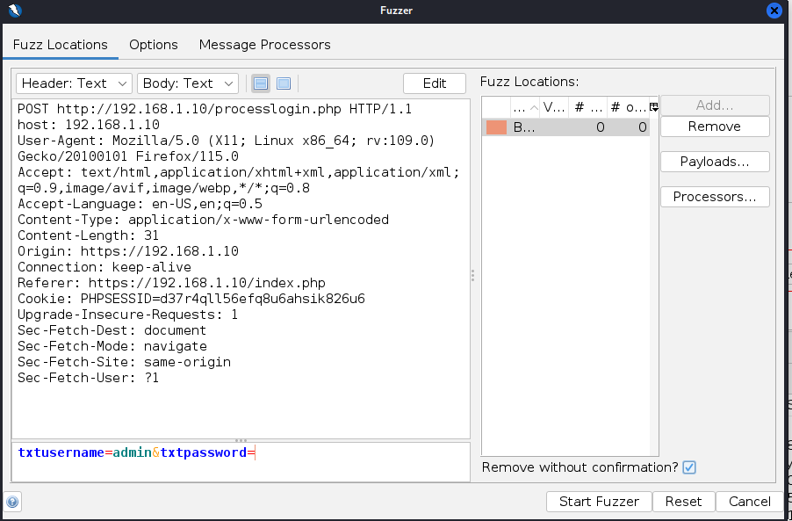

Figure 29 - Fuzz tool for bruteforcing "admin"

Once the tester had crafted their request, they began to bruteforce the admin password, looking for a difference in response length. Eventually, the tester noticed that they had received a response with a different body length and paused the scan, and examined the request when they noticed that they had found the password for the admin account. They tester also noticed that they had sent over 40,000 requests to the web server over the course of a few minutes and therefore, were able to determine that there was no lock out mechanism present.

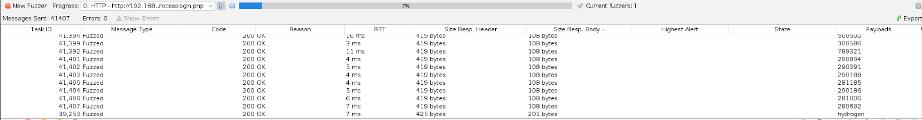

Figure 30 - ZAP showing a different response in bytes

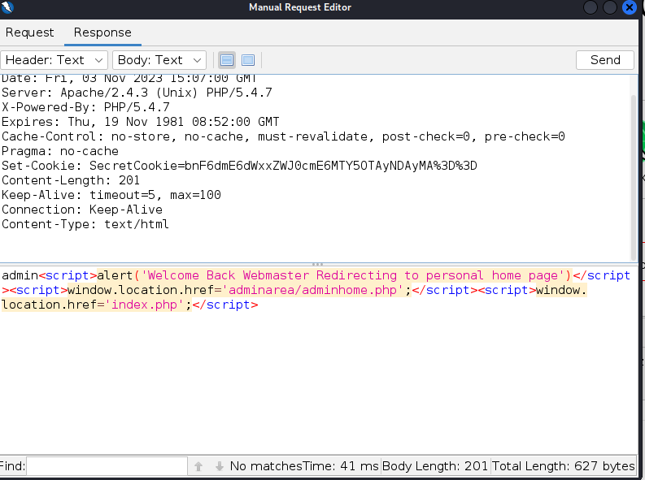

Figure 31 - The response noted in Figure 29

### Testing for Weak Password Policy

Whilst performing other tests the tester had made note of the password policy for the website, noting that there were no requirements besides there needing to be a minimum of 5 characters and a maximum of 10 characters. The limit of 10 characters was enforced due to the password form not allowing the user to input anything over 10 characters, with the minimum of 5 being established by a pop-up that generated if the user tried to enter in another field whilst the password or confirm password fields were less than 5 characters long.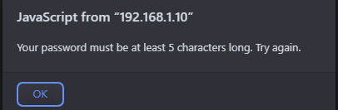

Figure 32 - Minimum password length popup

## Authorisation Testing

### Testing Directory Traversal File Include

Due to the way that web applications operate they are often calling data from other parts of the website, and such, depending on how this is done may be allow it to be manipulated. The tester had noticed that one page in particular loaded other files through a query in the URL bar, this was the “Delivery Information” tab presented at the bottom of the website. Once the tester loaded the page, they noticed that the PHP file on that page took one field “type” followed by a file.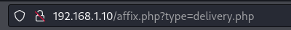

Figure 33 - Affix.php query

The tester knew that the server was hosted in a Linux machine and therefore wanted to try and load the file “/etc/passwd” which contains information regarding the accounts on the Linux machine and may include password hashes, depending on the set up of the server. To complete this the tester replaced “delivery.php” with “../../../../../../etc/passwd”. The reason that the tester included multiple “../” before inputting the file they wanted was to navigate through the filesystem, as web servers are often hosted in the directory “/var/www/html” they would need to move back through the directory before being able to go up through the tree. The tester then pressed enter and the contents of the “/etc/passwd” file was loaded, proving that there were capabilities to read any file on the system.

Figure 34 - Proof of Directory Traversal with /etc/passwd

## Session Management Testing

### Testing for Session Management Schema

As the tester mentioned in Section 2.5.1, the tester had noticed the creation of a cookie called “SecretCookie”, and due to the HTTP protocol being used on this website, this cookie was available for the tester to grab and attempt to reverse engineer. The tester noticed that this cookie appeared to be encoded in Base64 and used the online tool created by GCHQ, CyberChef, to decrypt the cookie and the output can be seen in Figure 35.

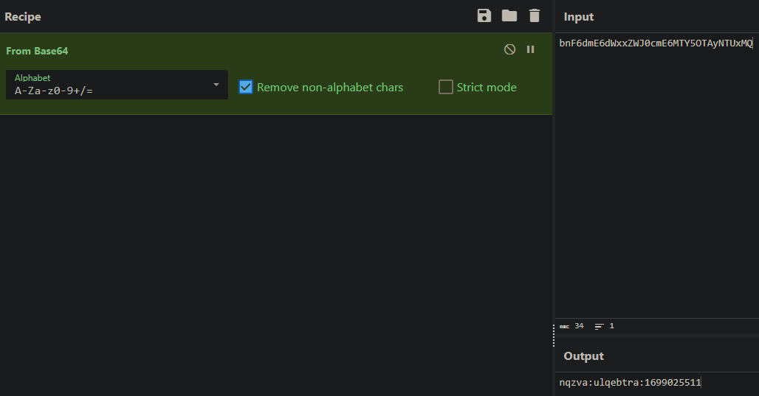

Figure 35 - CyberChef showing the decryption of the SecretCookie

The tester noticed that the contents of the first two sections of the cookie were the correct length in characters for the admin credentials, although were not the admin credentials, and was unsure on the third portion of the cookie although after some testing noticed that the first two sections were encoded in “ROT-13” which is a common cipher which rotates the characters a certain amount of letters further in the alphabet then their current position. For example, using ROT-13 the character “A” would become “N” because “A” is the first character in the alphabet and “N” is the 14th character. After decoding the ROT-13 encoded sections, the tester was greeted with the admin credentials.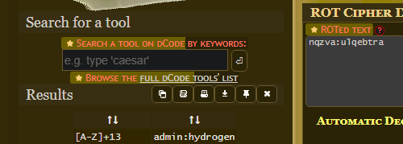

Figure 36 - Showing the admin credentials were encoded in ROT-13

The tester decided to look more into the final section of the cookie in the following section.

### Testing for Cookie Attributes

The tester was unsure on what the number at the end of the cookie meant but wondered whether it could be related to the time that they had created the cookie, and whether this was a UNIX timestamp. After using an online converter, the tester was shown that it was, indicating the time that the cookie was set was the contents of the final section of the cookie.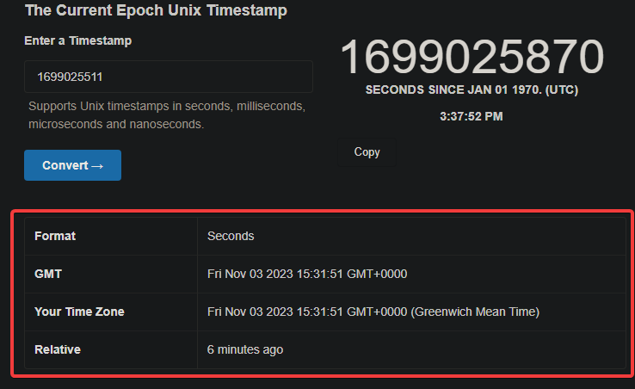

Figure 37 - Unix Timestamp showing the time that the login happened

### Testing for Session Fixation

Session fixation is a synonym for cookie hijacking, which is the process of taking over another account without going through the correct authentication processes which, in this case, would be through the login page. The tester tested whether they were able to bypass the intended login processes by first, logging into the account credentials they had been provided and storing the “SecretCookie” that would be created, followed by logging out of their account and manually adding the cookie to their browser, to see whether they would then be logged back in as the “Hacklab” user.

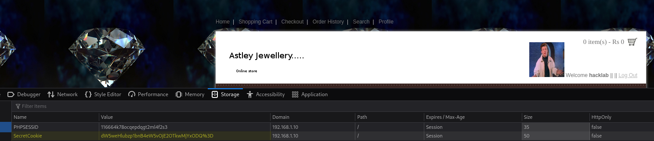

Figure 38 - Part 1, copying the cookie for the "Hacklab" user

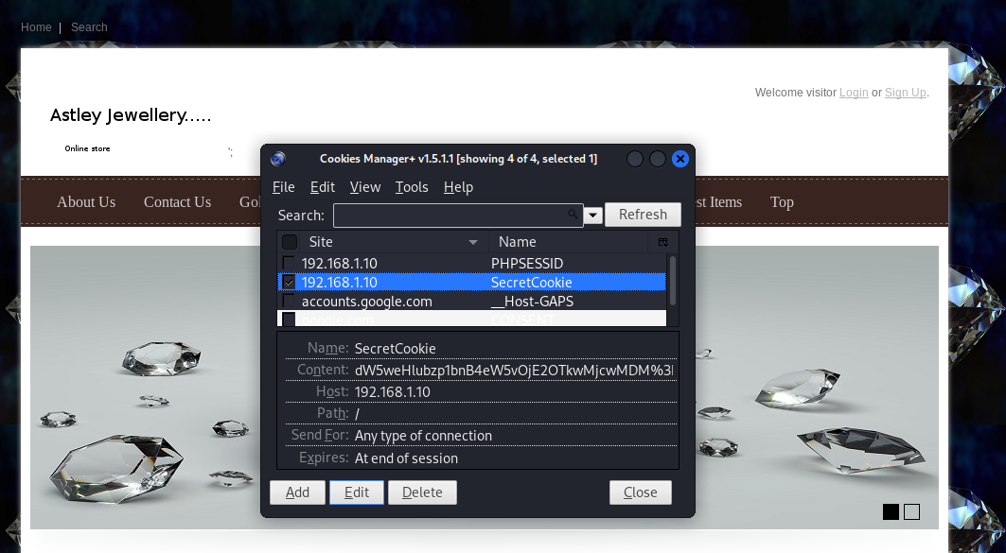

Figure 39 - Part 2, creating the "SecretCookie” with the value copied from Part 1

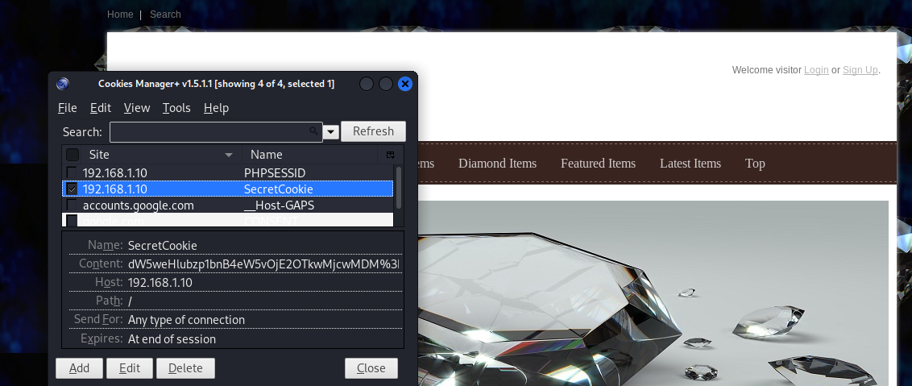

Figure 40 - Part 3, the exploit was unsuccessful

The tester had shown that they were not able to perform a session hijack by copying the contents of the cookie and creating a variable.

### Testing for Logout Functionality

To test the logout functionality of the website, the tester needed to access a page that both required authentication and had the capability to log them out, to which they chose the “Add to cart” page for an item. The tester then planned to log out of their account and see whether they could still access this page, as it would indicate whether the logout function had worked appropriately or not. What this test aimed to show was whether, if a user was to change their password due to a malicious actor having access to their account, whether they would be logged out of the account or not.



Figure 41 - Accessing a page that should require authentication whilst not being logged in

## Input Validation Testing

### Testing for Reflected Cross Site Scripting

From the testers OWASP ZAP scan, that can be found in Appendix B, the tester was able to identify that the website was vulnerable to cross site scripting (XSS). XSS is a form of attack where code is injected into the browser through a user input field. Reflected XSS focuses on “non-persistent” XSS, which means that it is delivered and executed in the same request, whereas stored XSS is delivered and executed in separate requests.

As shown in Figure 42, the tester input a basic reflected XSS payload into the search input field and when the tester clicked, “search” their payload was successfully executed and generated an alert from the webpage, with the contents “1”.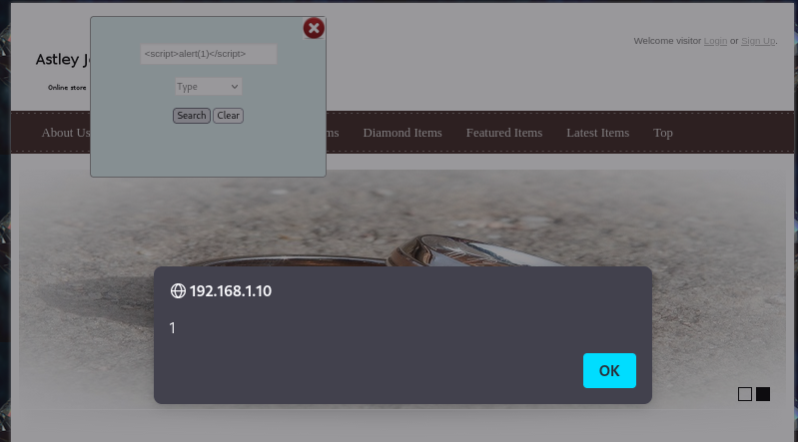

Figure 42 - PoC for Reflected XSS

### Testing for Stored Cross Site Scripting

As mentioned in the above section, the tester was going to test for somewhere on the site where they could upload a piece of malicious code that, when loaded, would trigger an XSS payload. For this tester, the tester intended to create a new account and set the “name” field to their XSS payload, and then log into the admin account, and load the database, to see whether this would execute their payload. 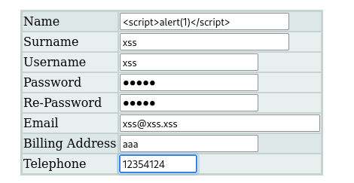

Figure 43 - Payload for Stored XSS

After submitting their account, there was no errors and their user was successfully created. The tester then logged into the admin account and attempted to load the “viewusers” page when they were greeted with an alert containing their payload, showing that they had a proof of concept for stored XSS.

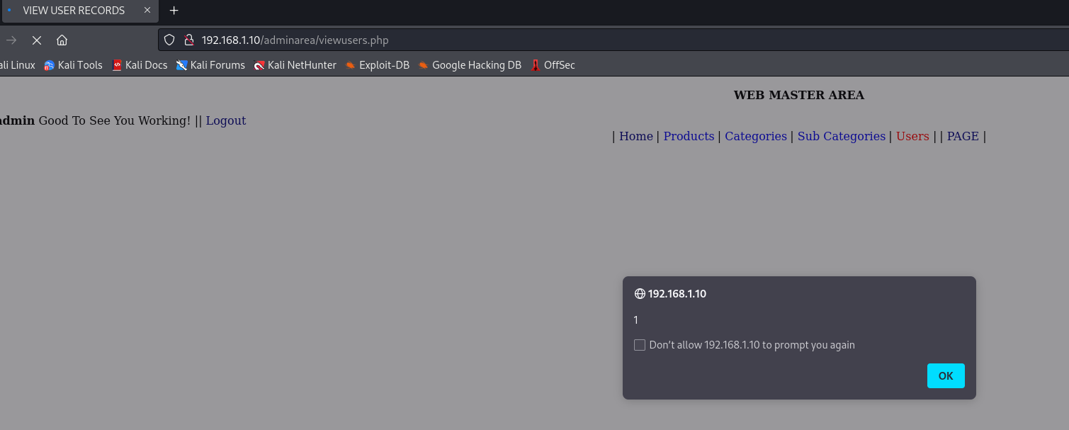

Figure 44 - PoC for Stored XSS

### Testing for SQL Injection

The tester had identified through looking for various kinds of blind SQL injection (SQLi) that the website was vulnerable to “time based SQLi”. Time based SQLi is a kind of SQLi that utilises the “sleep” function to show that the users query is interacting with the database.

The tester used various syntax to create a query that would show a proof of concept regarding time based SQLi and eventually found that “ ' or sleep(5)# “ was a valid payload in the “username” field when attempting to log into a user account. By inputting a random username and then the query mentioned above, the webpage would hold for 5 seconds before eventually returning an alert box telling the user that they had not inputted a valid password and therefore could not log in. A screenshot showing this can be found below in Figure 45.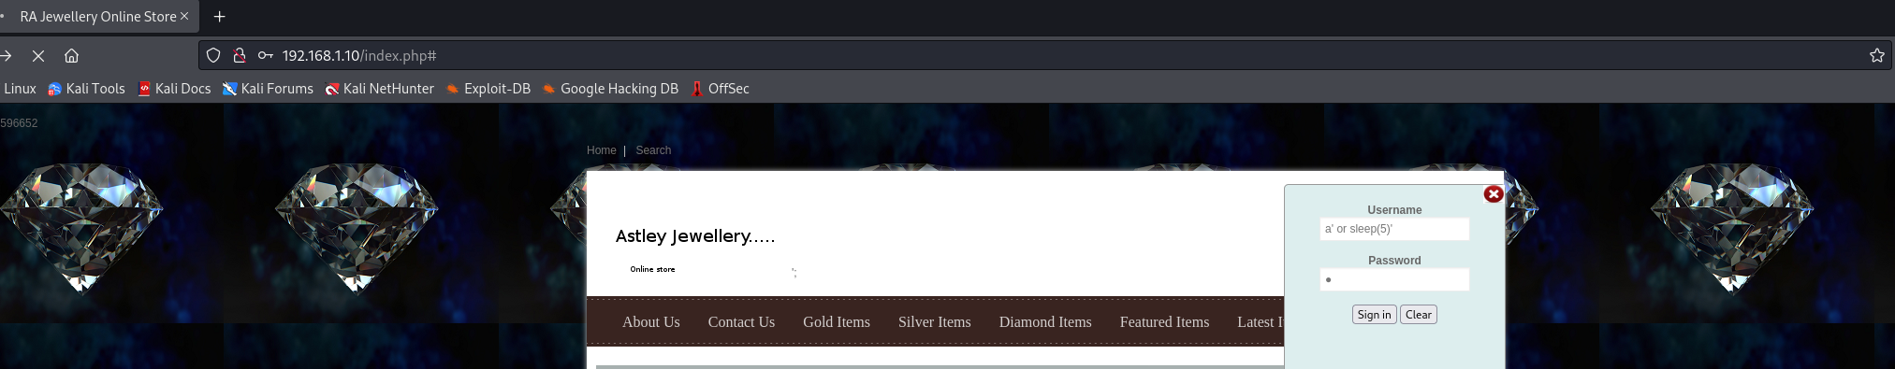

Figure 45 - PoC for Time Based SQLi

### Testing for Incubated Vulnerability

Through the tester’s exploration of the webpage, the tester had noticed that once logged into an account, they had the capabilities to upload a new profile picture for their account. The tester wondered whether they could perform a Local File Inclusion (LFI) vulnerability and upload malicious code to the website, when chained with the directory traversal vulnerability they had found and documented in 2.6.1. The tester created a small piece of HTML that would display a heading that said, “This website is vulnerable to Local Fle Inclusion”. 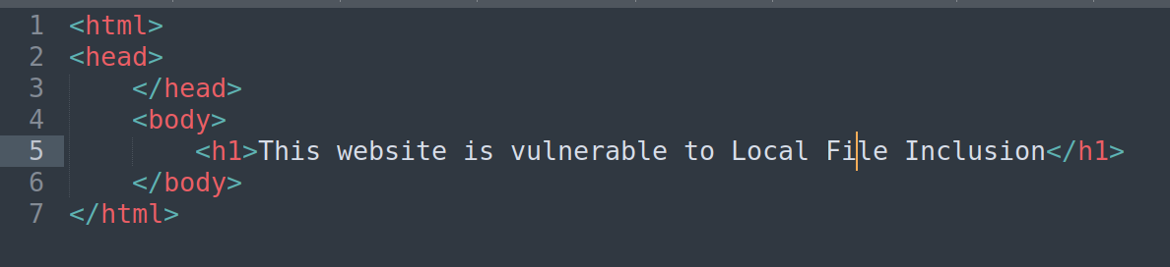

Figure 46 - Contents of malicious HTML file

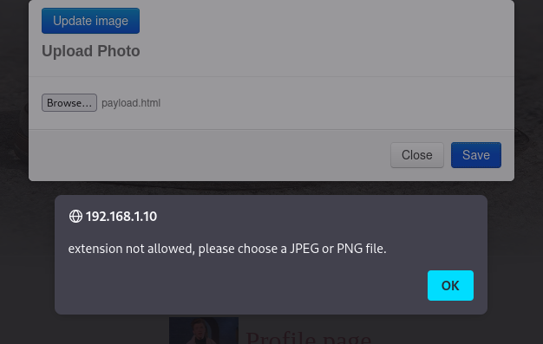

Figure 47 - Attempting to upload payload.html

Although upon trying to upload the malicious HTML file, the tester was greeted with an alert which told the tester that they must upload a JPEG or PNG file. To test how thorough this protection system was, the tester changed the file path to .html.png and attempted to upload again.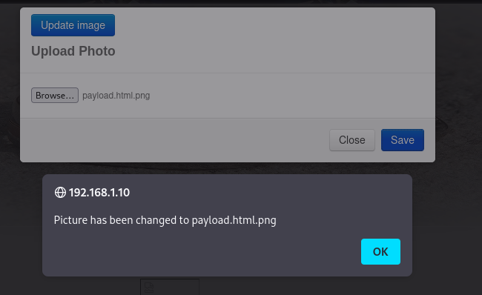

Figure 48 - Attempting to upload payload.html.png

After successfully uploading their malicious code to the website, the tester needed to find where it was stored, which could be done through the developer tools of their web browser, to which they learnt their file was stored in the “pictures” folder. Knowing this information, they went to the delivery information section and attempted to upload their code.

Figure 49 - Chaining LFI with Directory Traversal

The tester had confirmed that they were able to maliciously upload and then execute their own code on the server. This section also covers 4.7.11 & 4.7.12 of the OWASP methodology.

## Error Handling

### Testing for Improper Error Handling

Improper Error Handling refers to leaking information which could provide someone malicious with further information about the structure of the services running on the server, although having been previously identified through nmap, the tester noticed that upon trying to load a resource that did not exist, they were presented the PHP and Apache version that was running, which further confirmed the information retrieved from nmap earlier in the test.

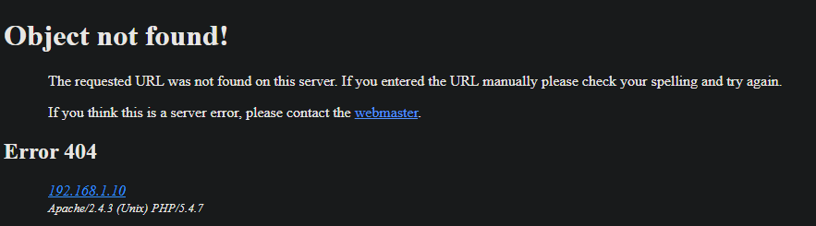

Figure 50 - Output when trying to load a resource that does not exist

## Testing for Weak Cryptography

### Testing for Weak Transport Layer Security

As previously identified in the penetration test, the website does not have a TLS or SSL certificate and therefore does not support encrypted traffic, which can be identified by the lack of padlock in the top left of the URL bar when loading any page on the website. The tester checked further for any presence of SSL or TLS through the use of the package “sslscan”. The output of their command can be seen in Figure 50.

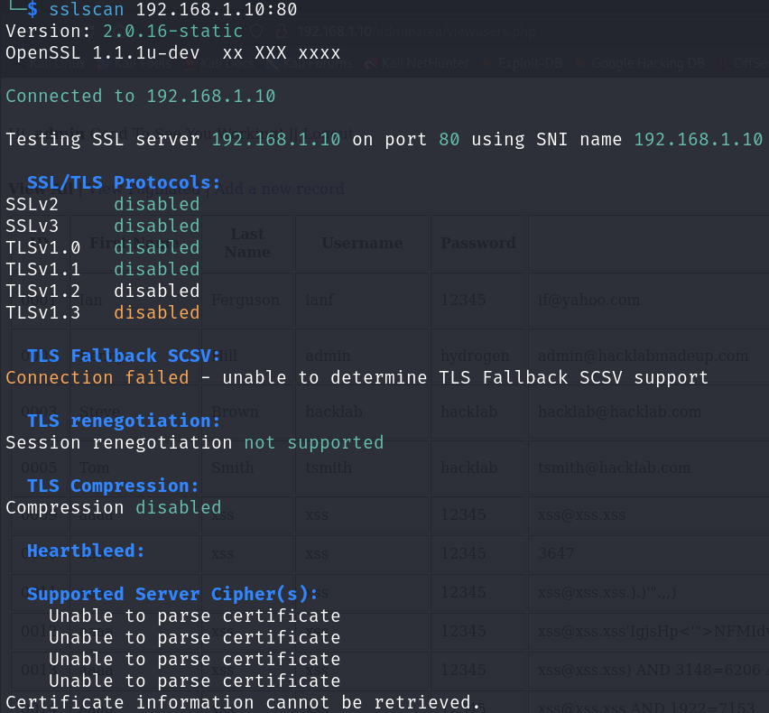

Figure 51 - Output of sslscan

## Business Logic Testing

### Test Business Logic Data Validation

For this part of the methodology, the tester looks to test whether they can input pieces of data that do not belong in the form area they have been entered into. For example, text into a phone number field, or an address that is not in a valid format. As the tester had previously shown, they were able to use the address “aaa” which is not valid in any format, therefore showing that there is a lack of logical data validation. An example of this can be found in Figure 52.

Figure 52 - Lack of logical data validation

### Test Ability to Forge Requests

The tester had shown throughout this report that they were able to submit requests to the webserver that contained malicious code through XSS, SQLi and LFI. Through these vulnerabilities the tester has proven that they were able to gain access to data that would otherwise require the user to be authorised with valid credentials, including admin functionality on the application. This can be found in Figure 33 and Figure 44.

### Test Number of Times a Function Can Be Used Limits

The tester has shown in section 2.5.3 that the application does not contain a lock-out mechanism and therefore there is no limit as to a number of times that a function can be used. This therefore means that these functionalities are vulnerable to brute force attacks as an attacker can make the same request an unlimited number of times and try different combinations until they stumble across a request that gives them access.

### Test Defences Against Application Misuse

The application contains some defences against a user misusing the application, an example of this could be with logging into an account. If a user alters the request when submitting data from a “POST” request to a “GET” request, they are greeted with an alert that tells them to fill the fields, and is then returned to the base page for the website.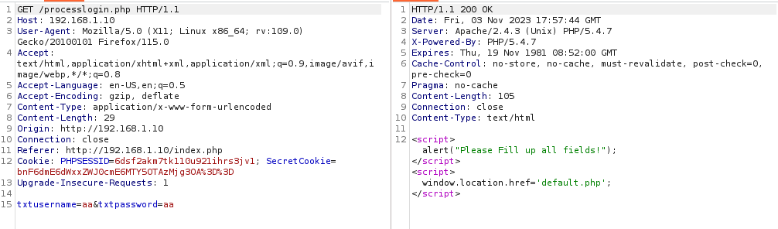

Figure 53 - Testing processLogin for misuse

### Test Upload of Unexpected File Types

As shown in section 2.8.4, the tester has proven that the security of the server to prevent users from uploading file types outside of what is expected is very lackluster and as such, allows a user to upload any code that they want to the server, as long as the suffix for their file is “.png” or “.jpeg”. This section of the testers report also covers 4.10.9 “Test Upload of Malicious Files” of the OWASP methodology as it shows a proof of concept for uploading malicious code.

# Discussion

## Overall Discussion

Throughout this test, the tester uncovered a number of vulnerabilities in the web application. The tester made use of the OWASP Web Application Testing Methodology to uncover these vulnerabilities and to test the website with a wide scope, attempting to cover as many possible vulnerabilities as possible by using a variety of methods and tools. It is worth noting that the tester identified a lot of the vulnerabilities in this web server to have been caused by service misconfiguration or poor user input checks.

The tester intended to go into great detail in the next section with covering each vulnerability and recommendations for the developer of the website as to how they can improve their website, and mitigate against the numerous vulnerabilities uncovered by the tester. The tester has also made note of other security concerns that are not necessarily related to the code of the server, including leaving private information publicly available and therefore potentially allowing for not only the risk of a breach in their online security but also the physical security related to the website.

## Mitigations for Vulnerabilities Found

### Robots.txt information leakage

The tester uncovered information leakage in the websites “robots.txt” file whereby the server owner had attempted to stop web crawlers and spiders from being able to find the contents of the “/company-accounts/” folder, but in term had meant that the presence of this folder had been made available to anyone conducting manual research on the target. Any user with this information is then able to browse to this folder and see the contents as there is no kind of password protection or authorisation checks.

The solution for this vulnerability is a mix of two solutions. The first solution is to remove any sensitive directories from the robots.txt file as it is always publicly available and therefore, to remove the “/company-accounts/” entry from the file and therefore users would be forced to stumble across the directory through spidering. The second solution is to add protection for sensitive folders, such as password protection or a login page. Due to the nature of the folder, this information should not be publicly facing on the website and adding some kind of password protection would prevent individuals who do not have the password from logging in and accessing sensitive information

### Source code information leakage

Throughout the application the developer has left numerous comments allowing for malicious actors to gain further information about physical and virtual details about the layout of components owned by the developer. The tester made specific notice of a door code that was stored in a comment on a webpage.

A simple way of mitigating this from being a problem is to have others review your code before it is uploaded to the live server as to prevent a developer from missing out on their own mistakes and allowing for multiple people to catch any errors that there may be.

### Installation files information leakage

Phpinfo is a PHP function that displays information the sites configuration including; OS information of the host, server information and other important information (Kinsta, 2022). This function is often used for debugging websites as they are in development and is included in a default install of PHP although, when the development stage of a website is complete the file should be removed as it can grant an attacker crucial information about the layout and environment of a web server, allowing them to target future attacks having gained additional knowledge about the target.

The mitigation for this vulnerability is to remove the phpinfo.php file from the webserver when the development stage of a website is done, before it is uploaded to the live server.

### No HTTPS

As mentioned throughout this report, HTTPS is a more secure protocol for websites as it encrypts data sent between a server and client, therefore preventing MITM attacks and allowing for attackers to steal sensitive user information such as passwords or banking details.

Assuming that the admin of the website already has an SSL/TLS certificate, then they are able to go into the config for their back-end software, in this case, Apache and edit the configuration files to include the necessary settings to cause for all traffic to be routed through HTTPS. The developer can navigate to their virtual host configuration file which is often stored on a Linux machine at */etc/apache2/sites-available* and editing the config to look like the code block below:

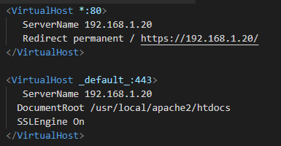

Figure 54- Code to force HTTPS over HTTP

After saving these changes to the appropriate file, the developer would then need to restart their server with */etc/init.d/httpd restart* and then all traffic that attempted to use HTTP would be forced to use HTTPS. (Ming, 2020)

### User Enumeration

When attempting to log into the website, the tester noticed that depending on whether they had entered a valid username, they would be greeted with a different error message compared to if they had provided an invalid username. If they had provided an invalid username, then the tester would be given the error message “Username not found” whereas, if a valid username but an invalid password, the tester would be shown “Password not found”. This could allow for a malicious actor to enumerate usernames on the website and then target further password attacks on specific accounts.

The solution for this vulnerability is to remove the separate error messages and instead create one error message that displays when either the wrong username or password is displayed. This would prevent malicious actors from gaining any information when trying to enumerate possible usernames as they would not be able to tell whether they had a valid username or not.

### Unlimited login attempts

The tester uncovered that whilst searching for the password for the admin account that they were able to attempt to log an unlimited number of times without any kind of prevention therefore meaning the login page was vulnerable to brute force attacks.

The tester recommends two main mitigations for this vulnerability. The first mitigation for this vulnerability is the introduction of rate limiting. Rate limiting is a method of controlling traffic flow to a service or server by restricting the number of requests that can be made within a certain timeframe (Redis, 2021). For example, if a user had attempted to log into their account 3 times within quick succession and not successfully logged in, then the server may block their IP address from loading the login page for 5 minutes, and gradually increasing the time that the IP was blocked from the site if the IP came back and failed to log in successfully to their account after another set of incorrect login attempts.

The other mitigation that the tester would recommend for this vulnerability would an account lockout which is similar to rate limiting, but rather would prevent any logins to the given account until manually unlocked either by entering a one-time password (OTP) which could be sent to the email or phone number associated with the account, or by clicking an unlock link that could be sent to the user. The benefit to this mitigation over rate limiting is that an attacker would not be able to use a Virtual Private Network (VPN) to spoof their IP address, and therefore bypass the mitigation. It is worth noting that this mitigation would still allow the attacker to execute a Denial of Service attack, as the requests would still have the capabilities to potentially take down the website functionality.

### Local File Inclusion (LFI)

LFI is a kind of vulnerability where an attacker attempts to trick a web application into running files on the server (Muscat, 2019). In this website, there was a vulnerability in affix.php, which took an argument, “?type=file.php” where the tester was able to call any server that was present on the server and therefore allowed for them to call any other file on the server such as the /etc/passwd file.

A solution for this vulnerability could be to implement a filter or whitelist. A whitelist would prevent all queries being sent unless they were one that was pre-defined, the disadvantage to this is that, as the site grew the whitelist would need to be altered and may become tedious depending on the amount of editing that is required. (Kovacic, 2021)

### Insecure cookie encryption

As seen in section 2.7.1, the server created a secret cookie that could be reverse engineered to show the current user’s username, password and a UNIX timestamp indicating when the user had logged in. This could allow for an attacker to hijack another user’s cookie and gain access to their account through cookie hijacking. The cookie followed a format of *username:password:UNIX*, where the entire cookie was encoded in base64 and the username & password fields were also put through a ROT-13 cipher. The format of the cookie can be found in Figure 54 below.

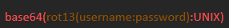

Figure 55 - Showing the layout of the cookie, "SecretCookie"

This vulnerability can be mitigated by using HTTP response headers to prevent the browser from caching the cookie and retrieving it from the server side. The developer could include the “HttpOnly” tag when creating the cookie, as this tag would prevent the browser from being able to access the cookie through JavaScript or XSS, as it would need to be sent via the HTTP/HTTPS protocols. (CookiePro, 2021)

### Directory Browsing

The tester made note through the penetration test of multiple directories throughout the webserver that, when loaded, instead of displaying a blank webpage as no specific resource was loaded, would instead load a directory containing a tree of every file within the directory, allowing for the tester to easily browse through the directory without having to search for any other files in the directory. Attackers are able to use this to gain more information about the targets structure and subsequently better focus future attacks as they have a better understanding of the layout of the webserver.

To mitigate this vulnerability, the developer would need to approach it with a different process depending on what backend software they were using. In this example, the developer is using Apache and therefore, they would need to create a “.htaccess” file and then navigate to the “httpd.conf” file and replace the configuration lines regarding these directories with the code found in the figure below. (Banach, 2019)

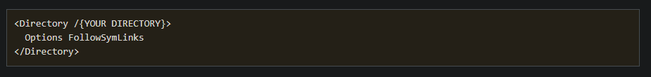

Figure 56 - Replacement contents for httpd.conf to prevent Directory Browsing

### File Filter Bypass

The tester uncovered a vulnerability where they were able to upload their own code to the server by exploiting a vulnerability in the functionality that controlled a user’s ability to update their profile picture. The tester was able to bypass the filter checks by adding a fake extension to the end of their malicious code, therefore not forcing them to upload a specifically allowed file type. This, chained with another vulnerability allowed for the tester to gain remote code execution on the server.

The tester recommends two methods for patching this vulnerability. The first of these mitigations being to check the Multipurpose Internet Mail Extension (MIME) type of the file. The testers bypass worked because the file extension is not relevant for a piece of code to execute, but rather the MIME type of the file, as that is what will determine how the code is handled by programs. Along with the checks for a valid filetype, the tester recommends implementing the PHP function *mime_content_type* which will fetch the MIME type of the file, and therefore check whether it is of a valid type. The developer could implement this solution by passing the file to the PHP function, having a whitelist of valid MIME types and then checking whether the MIME type was in the whitelist (R_Raj, 2019)

The other mitigation that the tester would recommend is setting up a separate server that stores the image files, therefore preventing from any malicious code attached to any image files from being executed on the server where the code is stored. This would have prevented the testers bypass from working as instead of loading code onto the server directly, it would have been called upon and therefore not executed. (OWASP, 2023)

### SQL Injection

SQLi is a vulnerability where attackers form malicious SQL queries and attempt to enumerate a database containing sensitive information such as account passwords. The tester was able to prove that the target was vulnerable to Time-based SQLi by which the tester used the payload *‘ or sleep(5)#’* which caused the website to hold the request for 5 seconds before submitting it.

The tester recommends blocking SQLi by using prepared statements. Prepared statements are used so that the server already knows the request as it has been prepared in advance so that all the user had to do is fill in the fields provided. The tester created some a mock statement that would prevent their attack from working, as can be found below.



Figure 57 - Replacement statements to protect against SQLi

By placing the “?” in the place of the user’s input, this will take the users input and replace them with the positions provided by the developer. In the second line, the command takes three flags, with the first specifying what kind of input to take, in this case “ss” indicates *string,string* meaning that both flags will be string and is then followed by the variables to pass into the statement, although if this were changed to “sb” it would mean *string,boolean*.

### Weak Administrator Credentials

The tester was able to use an open-source, well known wordlist to gain access to the admin account for the website. Given the functionality of the admin account and the fact that it has the ability to view all user data in plaintext and alter all parts of the website without any further checks, means that an account with so much power should have further restraints to protect the account further from the risk of being compromised.

Ideally all accounts, although specifically accounts with escalated privileges should be required to have long, complicated passwords that include special characters, numbers and a variety of upper and lower-case values as to prevent these accounts from being susceptible to brute force attacks. Furthermore, the tester would recommend implementing a 2-factor authentication system where accounts with escalated privileges are forced to enter a unique code upon logging in so that, even if their password is guessed, they are unable to log in unless they have the code.

### Cross-Site Scripting

The tester proved that they were able to perform both Reflected and Stored XSS attacks against the target on different sections of the website. The tester performed reflected XSS against a search function on the main webpage, and stored XSS against “name” function of the register function, which was then triggered when an admin loaded up the database.

There are many ways to patch XSS vulnerabilities and most mitigations are dependent on the specific payload and function. The tester recommended utilising HTML sanitisation, which is used to strip dangerous HTML from a variable and return a safe string. (OWASP, 2023). The tester also recommended looking into developing a more secure content policy through the user of headers that are sent with requests and advised the developer to create a content security policy (CSP) with the “Content-Security-Policy” header and preventing “unsafe-inline” scripts from running within the policy. (Firefox, 2023)

## Future Work

The tester believes that after the developer has gone away and implemented the mitigations suggested and done further research into any additional attack vectors that it may be worth conducting another penetration test against the target to ensure that the fixes had been implemented properly, and whether there were any vulnerabilities that were missed in the first test, that could be discovered a second time round.

Furthermore, on top of a second penetration test against the website, the tester would also recommend completing a penetration test of the business in a physical sense, testing the employees for social engineering and the security of the building itself. A physical test of the company would allow for the owner to gain an overview of other areas that they can focus on improving as, although the tester has completed a thorough test of the web application, there is always the possibility that in the real world, an attack could occur by someone attempting to break into the location where the server is stored and maliciously gaining access through the server, or potentially through the use of phishing emails and taking over an employee account.

# Bibliography

Banach, Z., 2019. *Invicti.* [Online]   
Available at: https://www.invicti.com/blog/web-security/disable-directory-listing-web-servers/#:~:text=You%20can%20disable%20directory%20listing%20by%20creating%20an%20empty%20index,parse)%20in%20the%20relevant%20directory.

CookiePro, 2021. *CookiePro.* [Online]   
Available at: https://www.cookiepro.com/knowledge/httponly-cookie/

Firefox, 2023. *MDN Web Docs.* [Online]   
Available at: https://developer.mozilla.org/en-US/docs/Web/HTTP/Headers/X-XSS-Protection

Kali Linux, 2023. *Kali Linux.* [Online]   
Available at: https://www.kali.org/tools/gobuster/

Kali Linux, 2023. *Kali Linux.* [Online]   
Available at: https://www.kali.org/tools/curl/

Kali Linux, 2023. *Tool Documentation.* [Online]   
Available at: https://www.kali.org/tools/nmap/

Keeper Security Inc, 2020. *Cybersecurity in the Remote Work Era.* [Online]   
Available at: https://www.keeper.io/hubfs/PDF/Cybersecurity%20in%20the%20Remote%20Work%20Era%20-%20A%20Global%20Risk%20Report.pdf

Kinsta, 2022. *Kinsta.* [Online]   
Available at: https://kinsta.com/knowledgebase/phpinfo/#:~:text=phpinfo()%20is%20a%20PHP,The%20PHP%20environment.

Kovacic, D., 2021. *Bright Security.* [Online]   
Available at: https://brightsec.com/blog/local-file-inclusion-lfi/

Lewis, R., 2023. *Office for National Statistics.* [Online]   
Available at: https://www.ons.gov.uk/businessindustryandtrade/retailindustry/timeseries/j4mc/drsi

Ming, 2020. *Stack Overflow.* [Online]   
Available at: https://stackoverflow.com/questions/16200501/how-can-i-automatically-redirect-http-to-https-on-apache-servers

Muscat, I., 2019. *The Acunetix Blog.* [Online]   
Available at: https://www.acunetix.com/blog/articles/local-file-inclusion-lfi/#:~:text=An%20attacker%20can%20use%20Local,to%20a%20file%20as%20input.

OWASP, 2023. *OWASP.* [Online]   
Available at: https://owasp.org/www-community/vulnerabilities/Unrestricted_File_Upload

OWASP, 2023. *OWASP Cheat Sheet Series.* [Online]   
Available at: https://cheatsheetseries.owasp.org/cheatsheets/Cross_Site_Scripting_Prevention_Cheat_Sheet.html

OWASP, 2023. *Review Webserver Metafiles for Information Leakage.* [Online]   
Available at: https://owasp.org/www-project-web-security-testing-guide/latest/4-Web_Application_Security_Testing/01-Information_Gathering/03-Review_Webserver_Metafiles_for_Information_Leakage

OWASP, 2023. *WSTG - Latest.* [Online]   
Available at: https://owasp.org/www-project-web-security-testing-guide/latest/

R_Raj, 2019. *Geeksforgeeks.* [Online]   
Available at: https://www.geeksforgeeks.org/php-mime_content_type-function/

Redis, 2021. *Redis.* [Online]   
Available at: https://redis.com/glossary/rate-limiting/

# Appendices

## Appendix A1 – Table of Abnormal Response Codes

|  |  |
| --- | --- |
| **File Path** | **Status Code** |
| /adminarea/ | 301 |
| /cgi-bin/ | 403 |
| /contact | 301 |
| /weblogic | 301 |
| /css | 301 |
| /font | 301 |
| /image | 301 |
| /includes | 301 |
| /js | 301 |
| /phpMyAdmin | 401 |
| /pictures | 301 |

## Appendix A2 – Table of Variable Fields

|  |  |  |
| --- | --- | --- |
| Pre/Post Login | Location | Field |
| Pre | Register.html | Name |
| Pre | Register.html | Surname |
| Pre | Register.html | Username |
| Pre | Register.html | Pw1 |
| Pre | Register.html | Pw2 |
| Pre | Register.html | Email |
| Pre | Register.html | Address |
| Pre | Register.html | Tel |
| Pre | Index.php | Username |
| Pre | Index.php | Password |
| Pre | Index.php | Select |
| Post | Profile.php | Name |
| Post | Profile.php | Surname |
| Post | Profile.php | Email |
| Post | Profile.php | Address |
| Post | Profile.php | Tel |

## Appendix B – OWASP ZAP REPORT

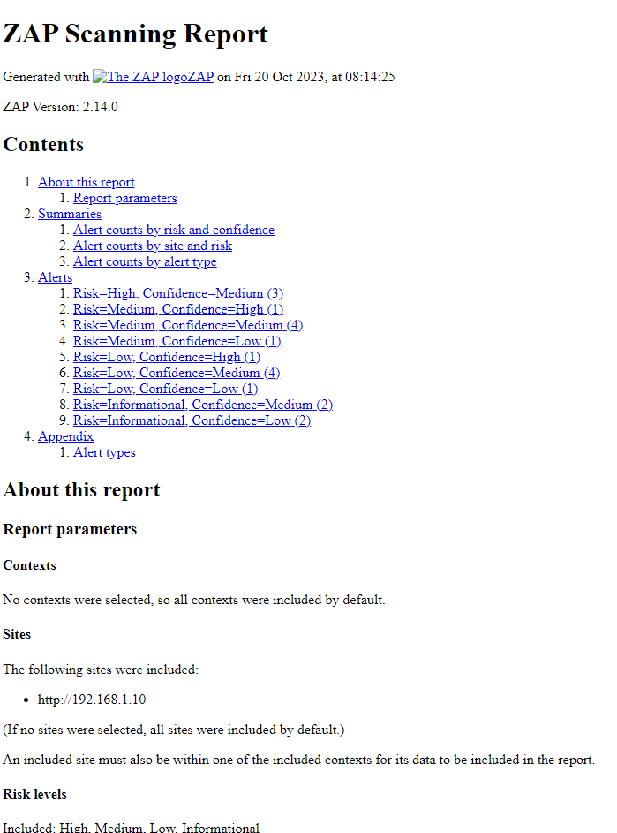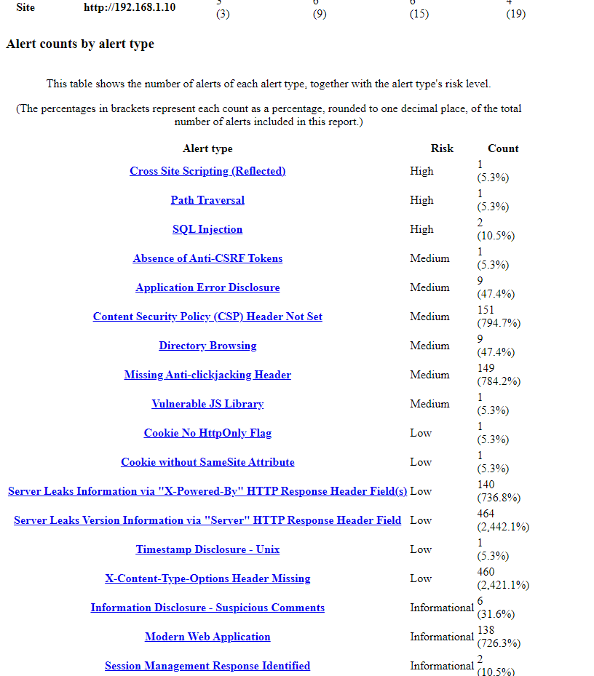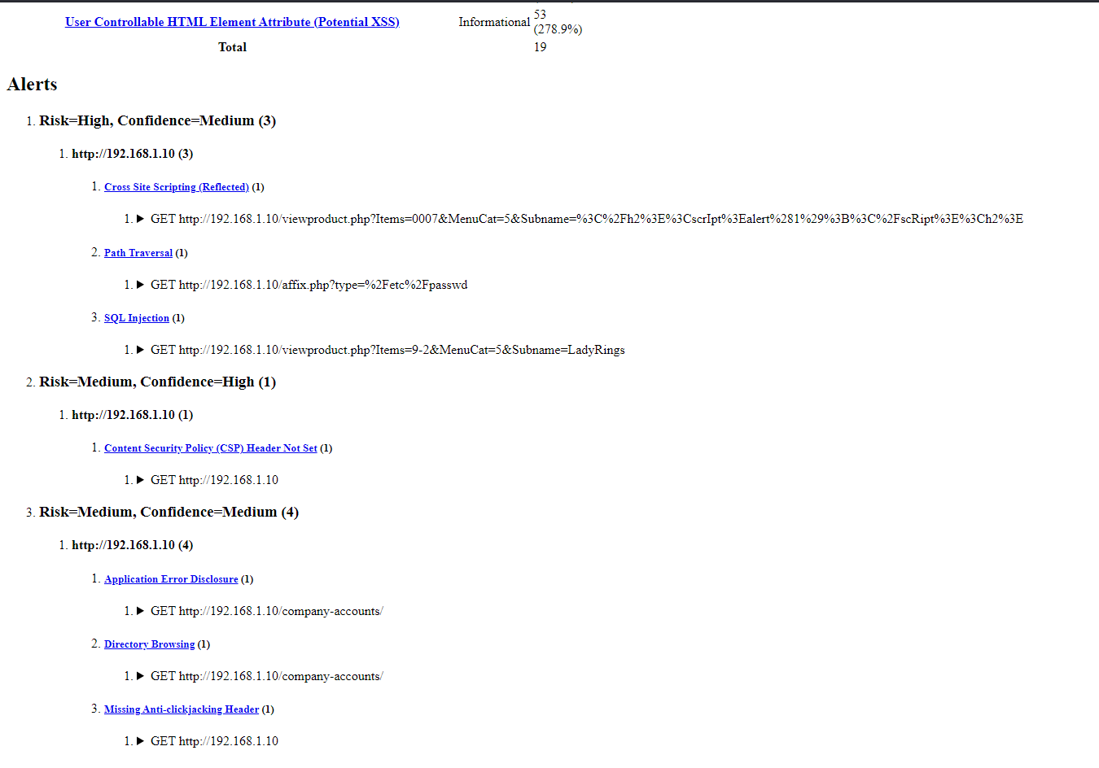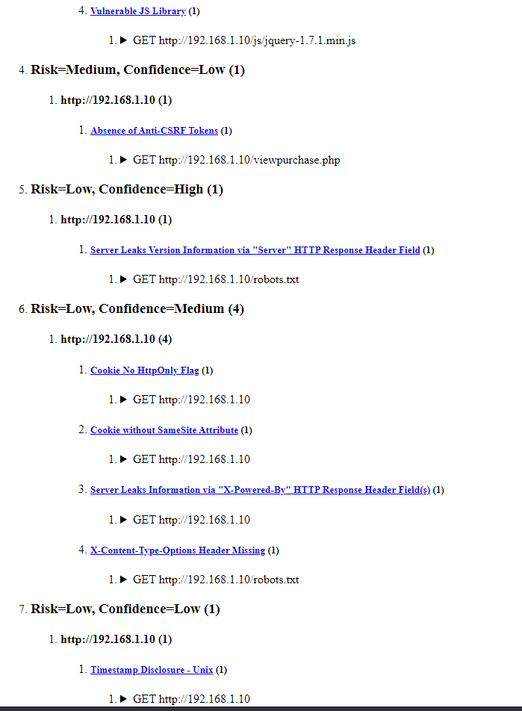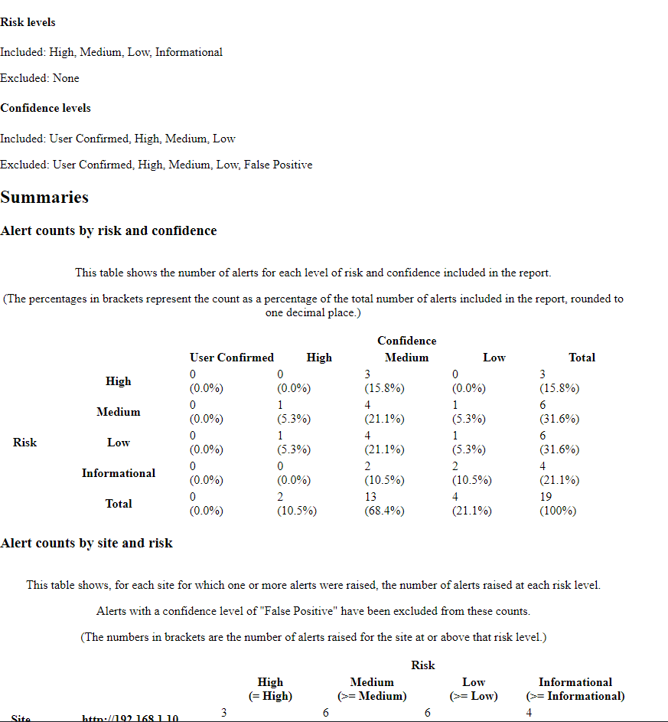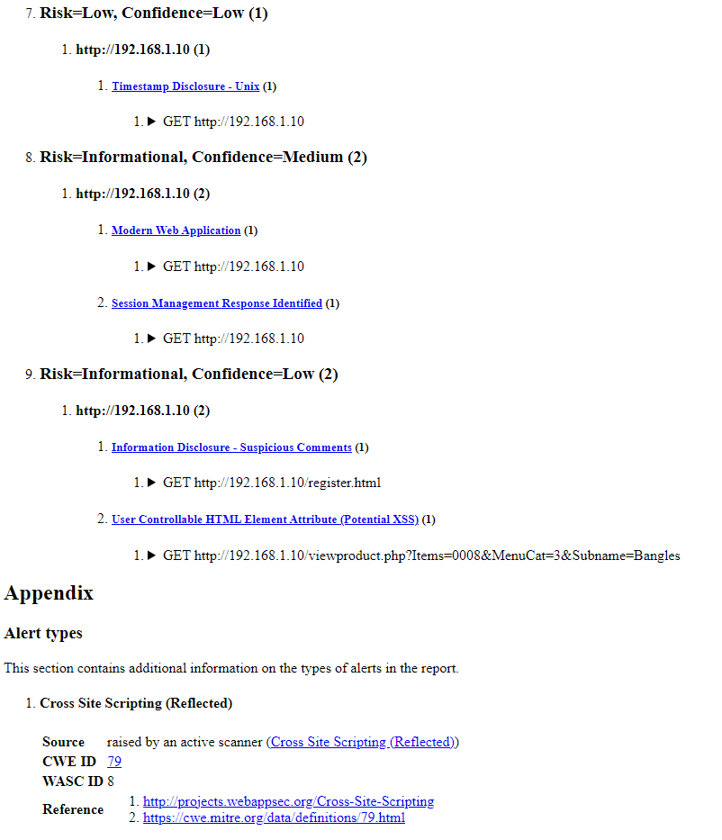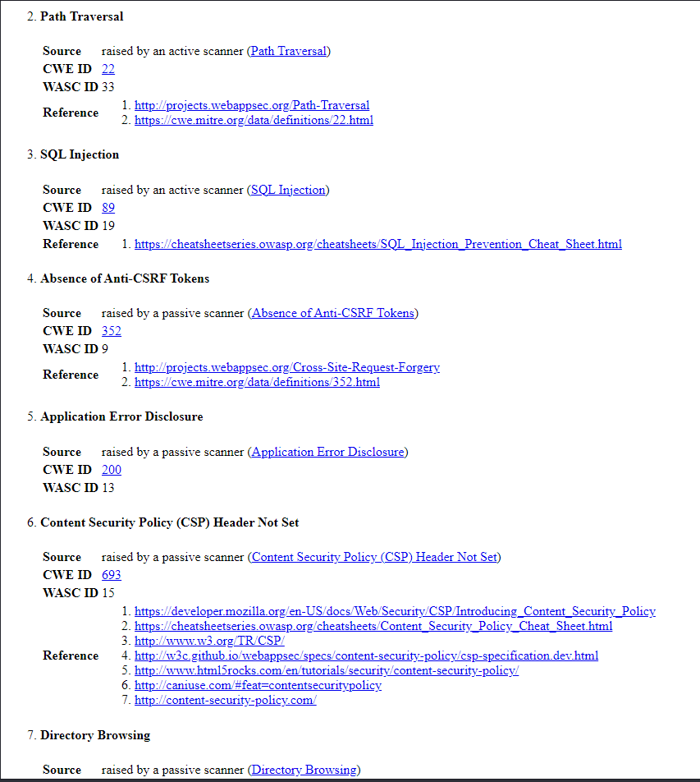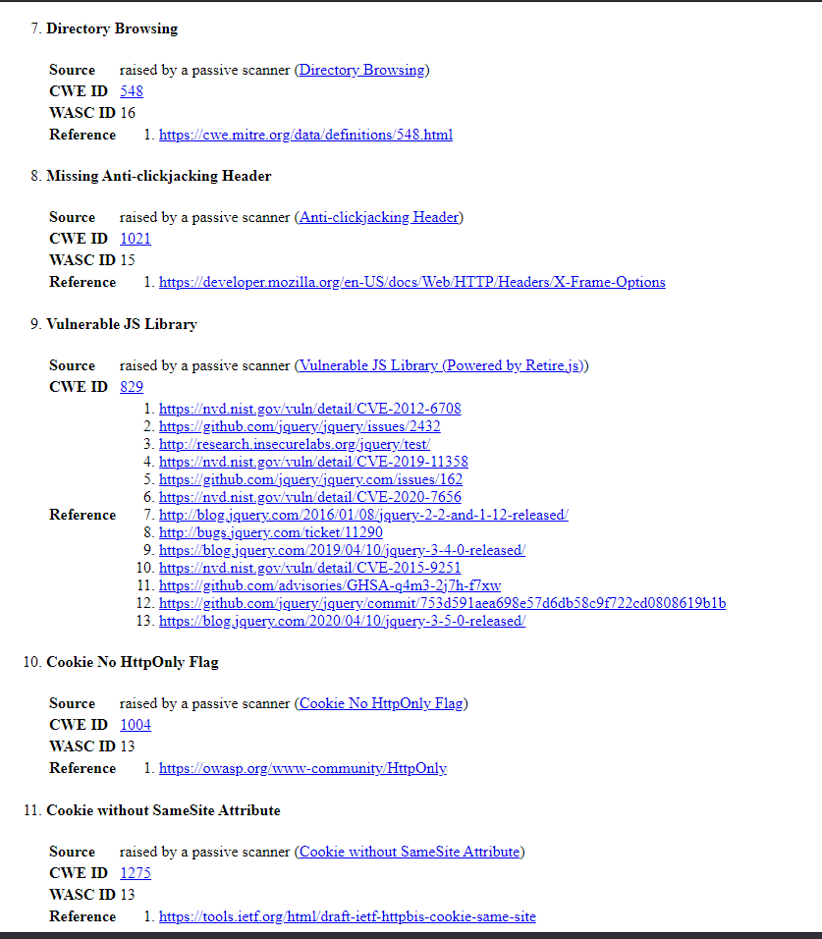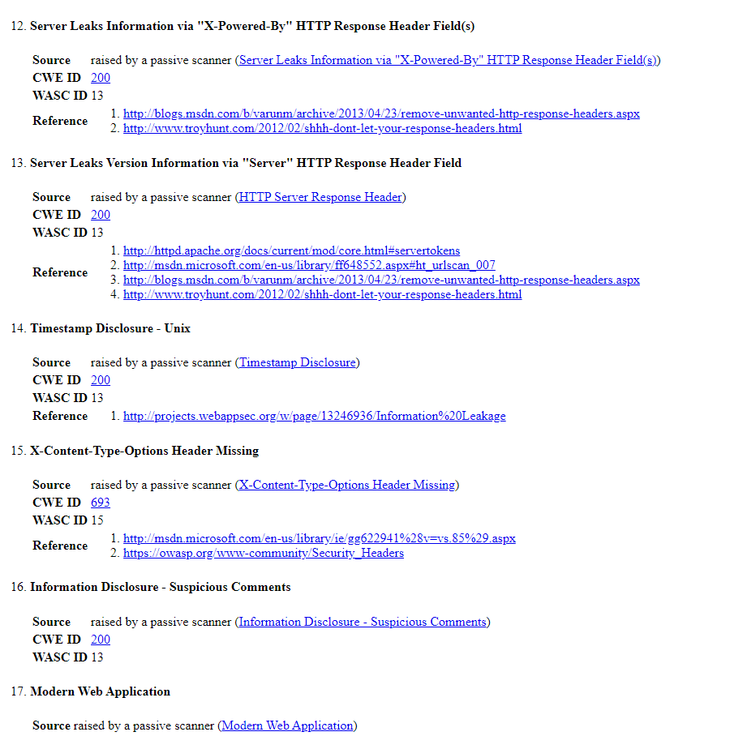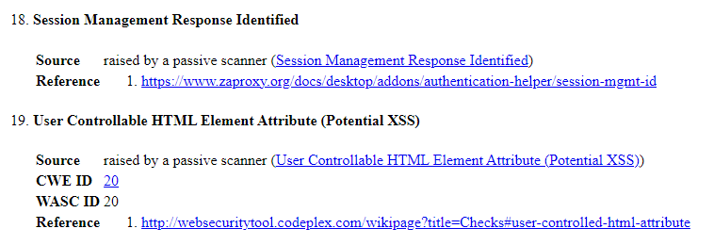

## Appendix C – Gobuster Output

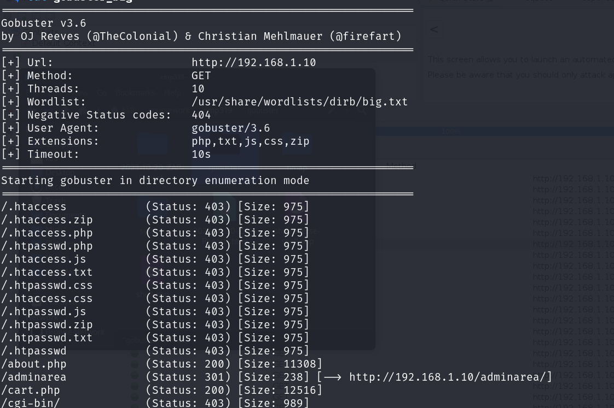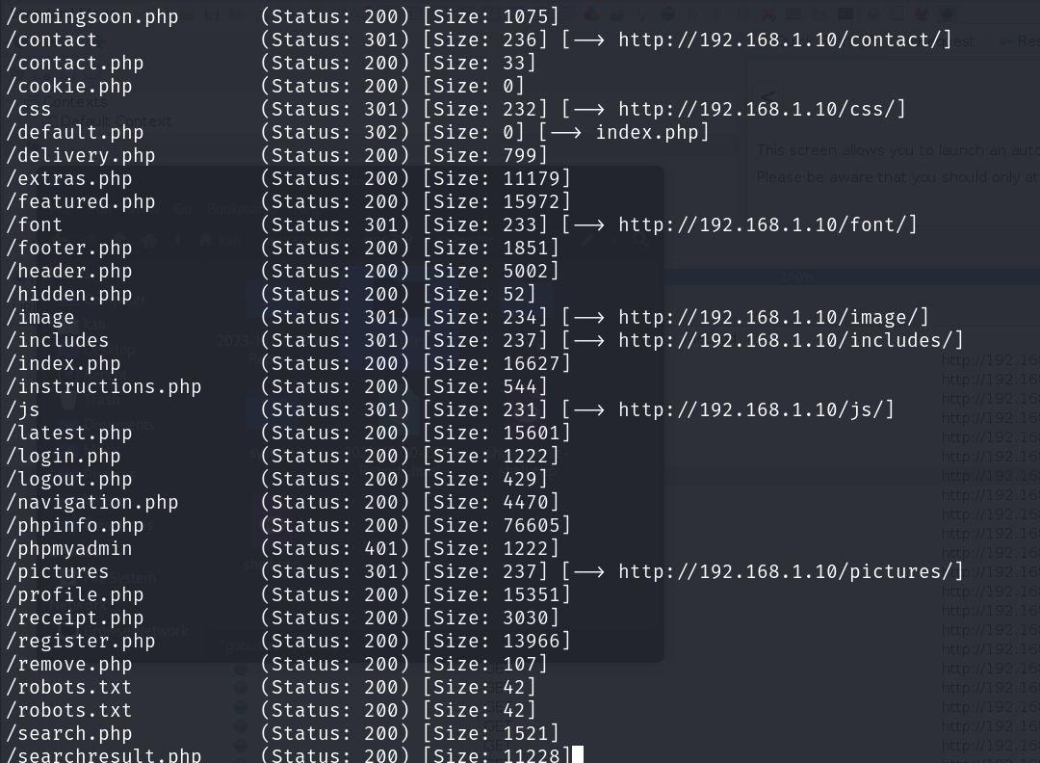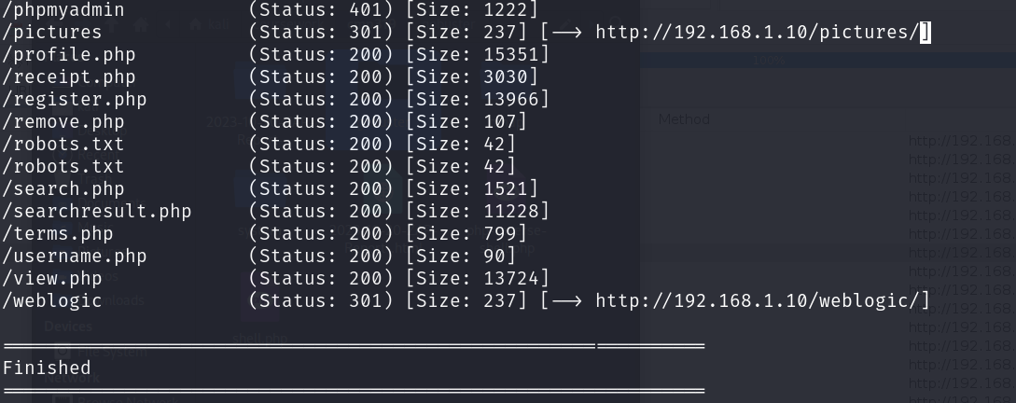

## Appendix D – Nikto Output

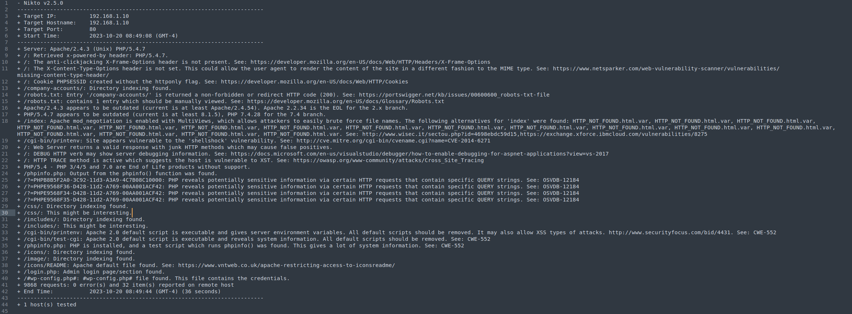

## Appendix E-1 – CSS Directory Contents

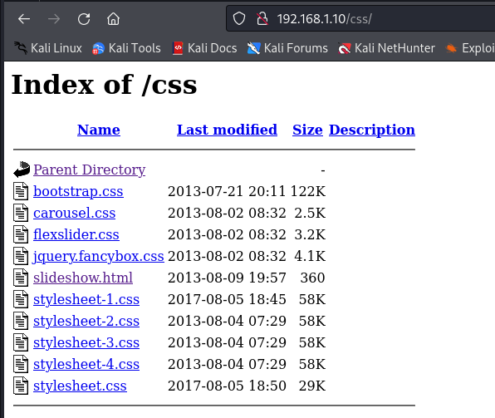

## Appendix E-2 – Includes Directory Contents

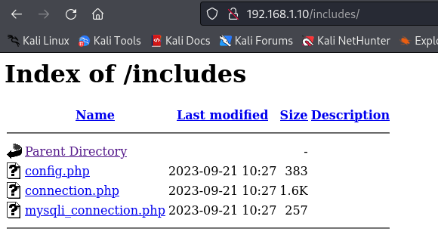

## Appendix E-3 – CGI-BIN Contents

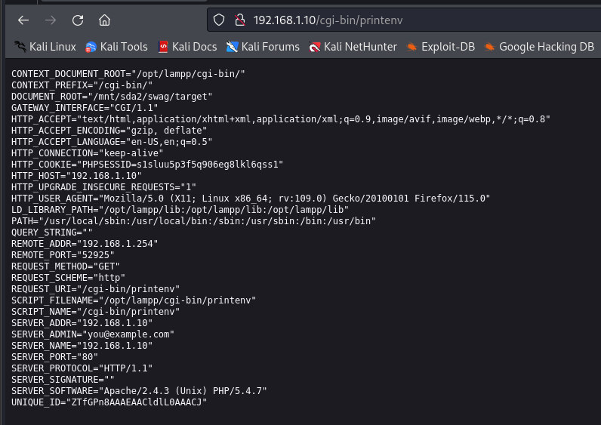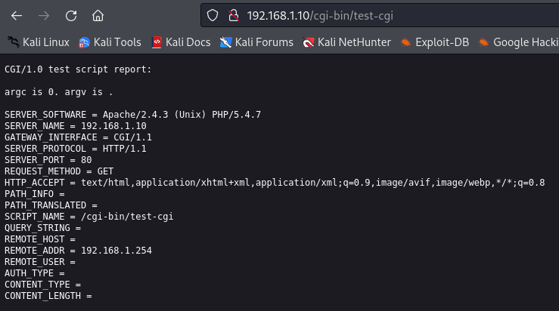

## Appendix E-4 – Icons Directory Content

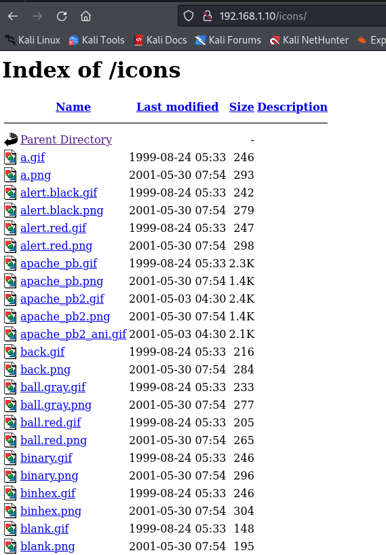

## Appendix E-5 Image Directory Content

